**Assignment Sheet**

**Assignment 1:- How to upload HTML web pages on Apache2 web server in EC-2 Instance? Please justify with step by step answers.**

Steps to host HTTP page

For Inbound

* Go to EC2 Dashboard ->security ->security groups
* Click on inbound rules
* Edit inbound rules
* Add new rules ->Type http & source 0.0.0.0/0
* Save rules

For outbound

* Go to EC2 Dashboard ->security ->security groups
* Click on outbound rules
* Edit outbound rules
* Add new rules ->Type http & source 0.0.0.0/0
* Save rules

Now copy the public IP of the instance and paste it to a new tab

**Assignment 2: Create readfile.sh in which you can read the information of PWD like size, permission, date time etc.**

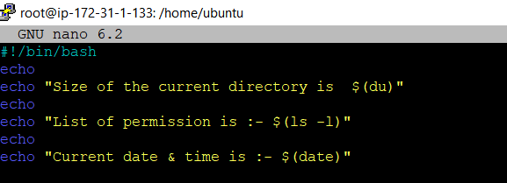

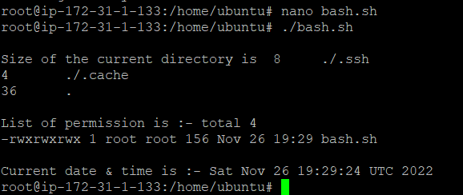

**Assignment 3: Take an input of name from user and print Have a great day ahead {name}**

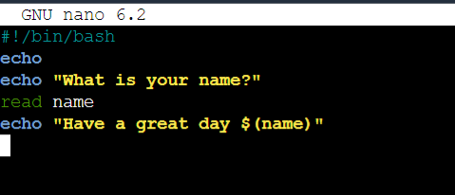

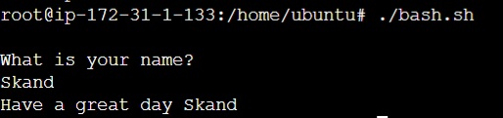

**Assignment 4: Let’s take a scenario of fintech app program in which we want to have three separate outputs for 3 different situations:**

* **The balance is less than zero**
* **The balance is zero**
* **The balance is above zero**

**For instance, in the following program, use the if, elif, else statements to display different outputs in different scenarios:**

**Use “if” condition to check if the balance is less than zero. If this condition evaluates to true, display the message using the echo command: “Balance is less than zero, Please add more funds else you will be charged penalty”.**

**If the above condition does not match, then use “elif” condition to check if the balance is equal to zero. If it evaluates to true, display the message: Balance is zero, please add funds**

**If none of the above condition matches, use the “else” condition to display the: Your balance is above zero**.

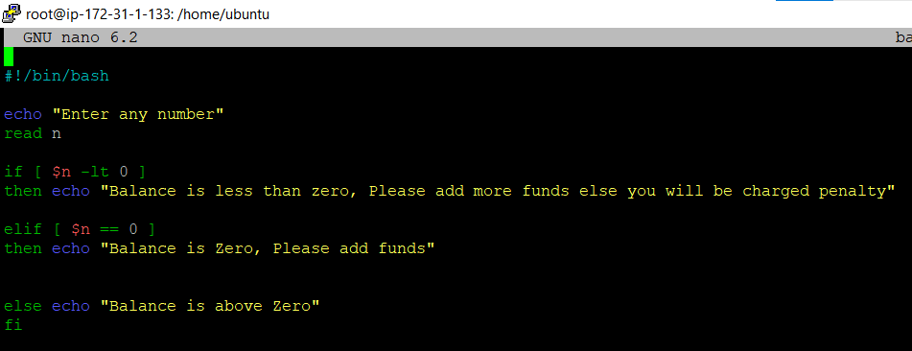

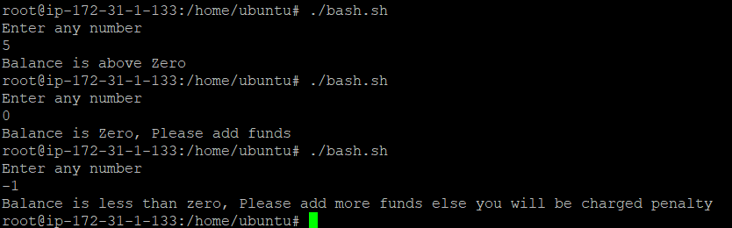

Assignment 5: Debug and define briefly about the following program: -

#!/bin/bash

# Print a message about disk usage.

space_free=$( df -h | awk '{ print $5 }' | sort -n | tail -n 1 | sed 's/%//' )

case $space_free in

[1-5]*) echo Plenty of disk space available

[6-7]*) echo There could be a problem in the near future

8*) echo Maybe we should look at clearing out old files

9*) echo We could have a serious problem on our hands soon

*) echo Something is not quite right here;;

esac

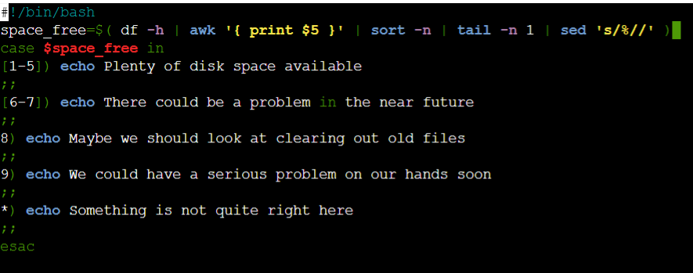

https://cdn.discordapp.com/attachments/993075127812100116/1047747478847492126/image.png